16.41: In terms of wavelength, Eq. (16.29) is
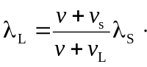
a) This is, of course, the same result as obtained directly from Eq. (16.27). The frequencies corresponding to these wavelengths are c) 431 Hz and d) 373 Hz.

